- Insert paper in the copier face up and oriented the way you would want to read it.
- From the copy screen hit the “Services Home” button
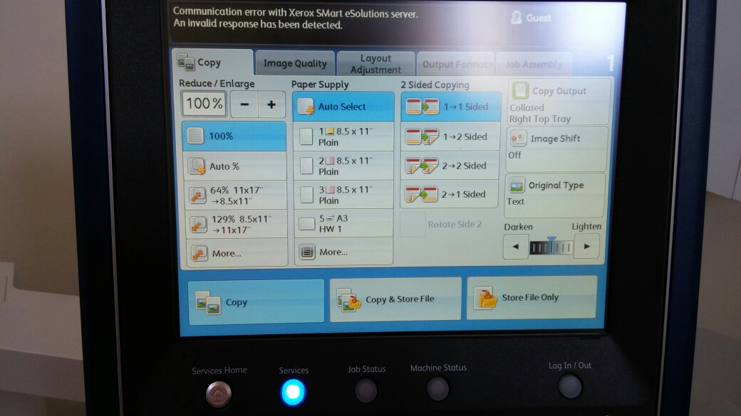
- From the Services Home screen select “E-Mail”
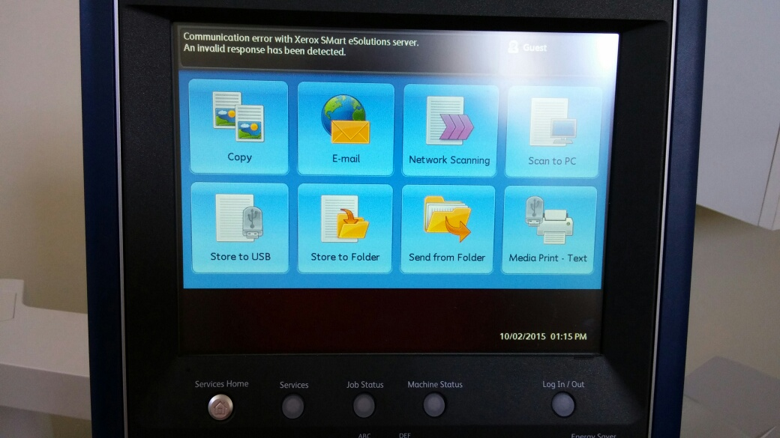

- On the E-Mail screen select “Address Book”
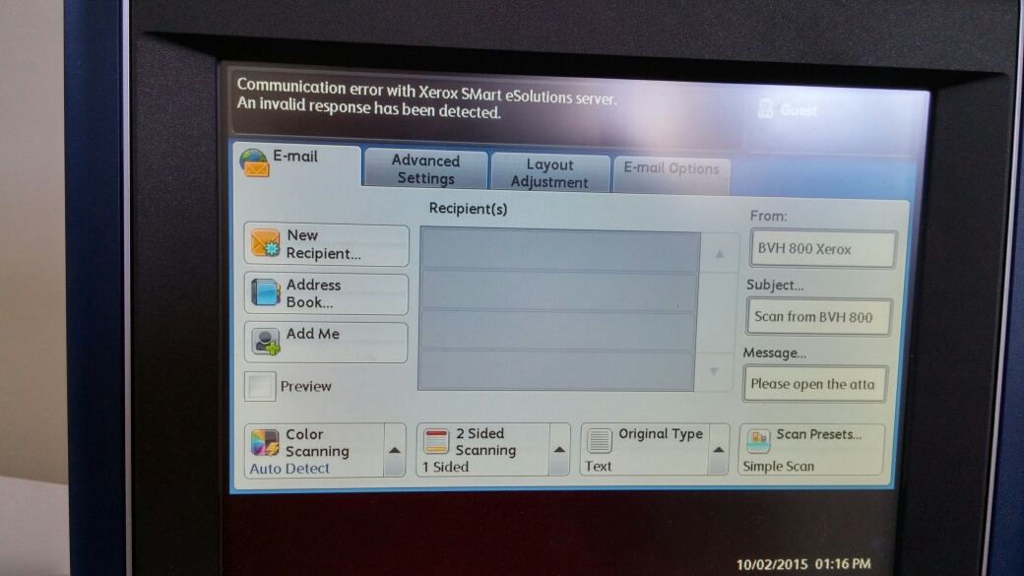
- On the Address Book screen use the arrows to scroll through the names in the address book. Tap the name you want and then tap “To”
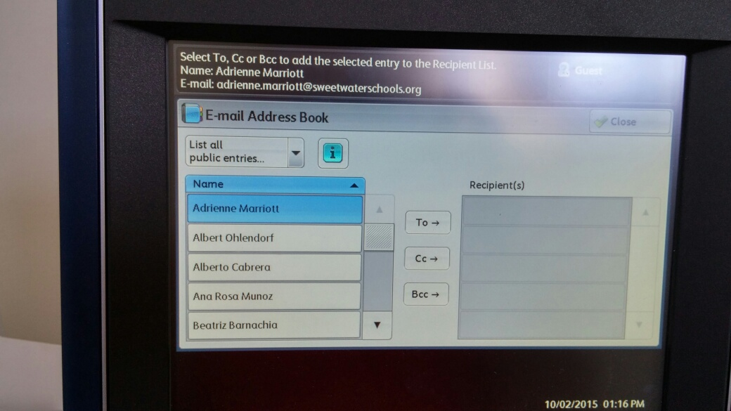

- Correctly selected names will appear on the Recipients list on the right. When done adding names select “Close”
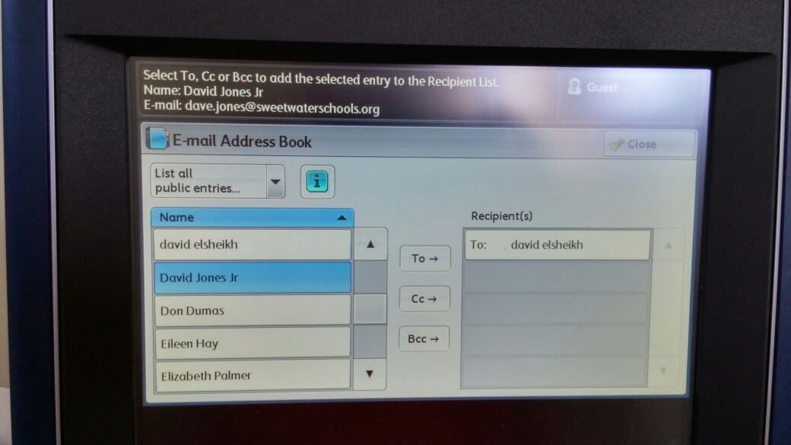
- You will be back at the main email screen with a recipient listed. Now select the “E-mail Options” tab
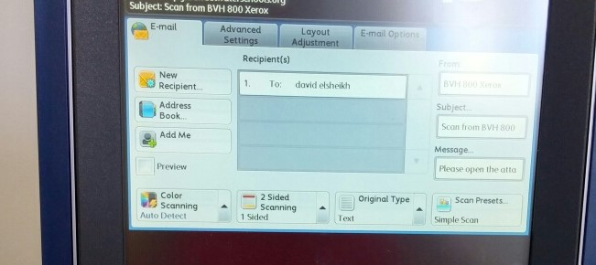

- On the E-mail Options screen select “File Format”
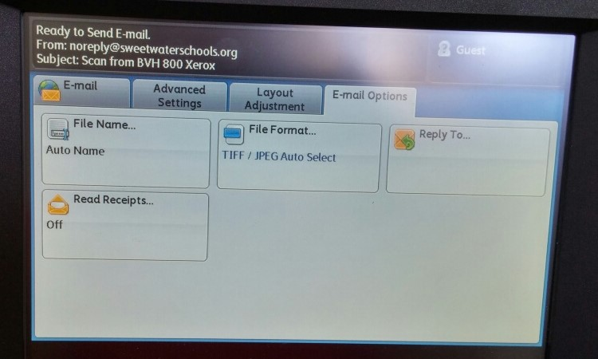
- On the File Format screen select “PDF/A” and then “Save”
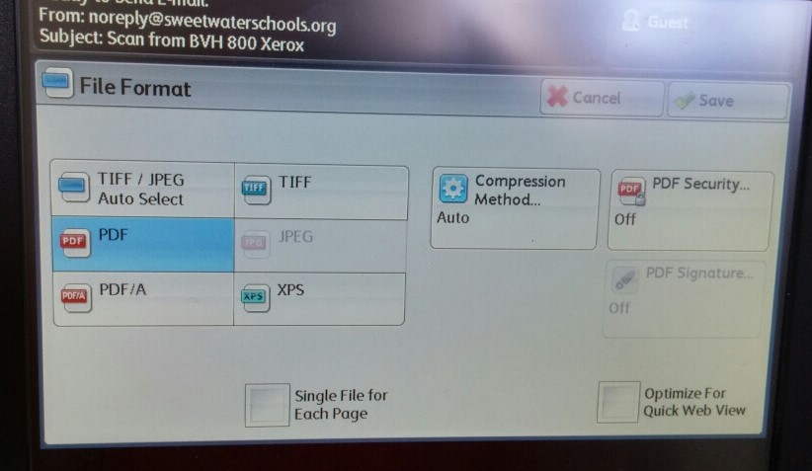

- You will be taken back to the E-mail Options tab. Select the “E-Mail” tab
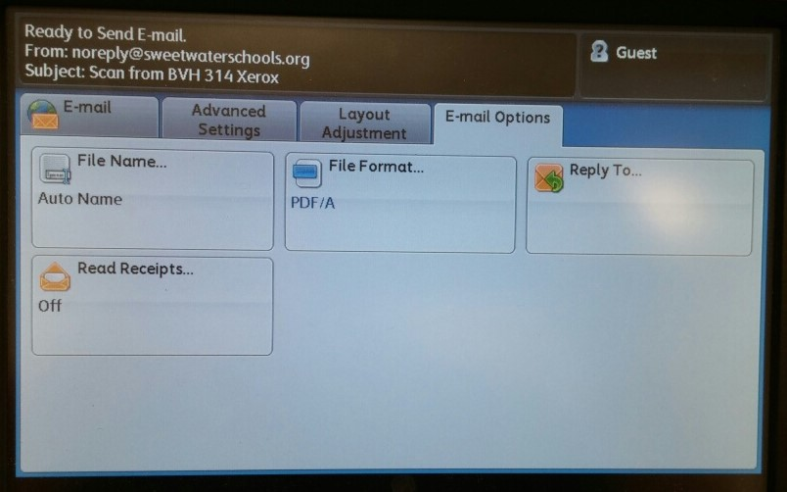

- Once back on the E-mail tab select the green “Start” button to start scanning the document as you would to make copies.